**Use Case Diagram**

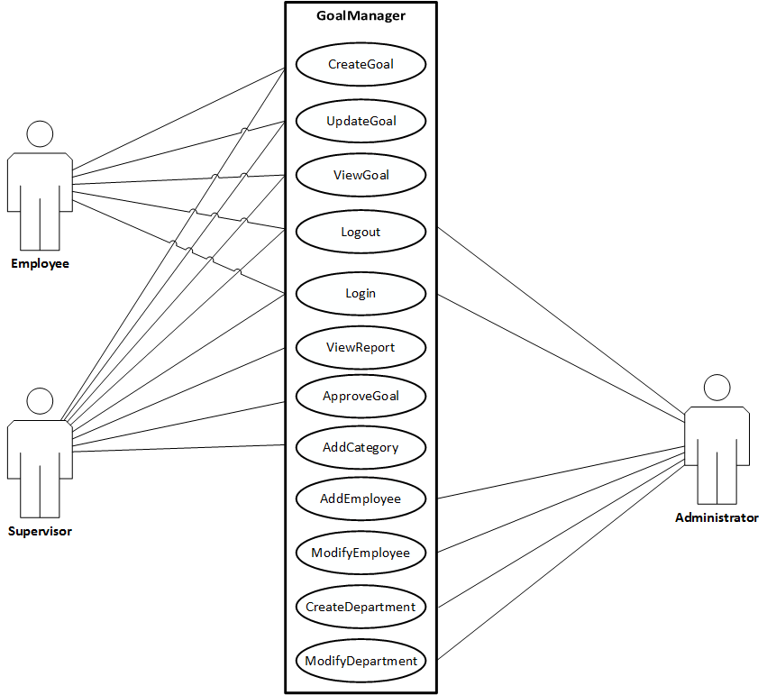

Employee

|  |  |
| --- | --- |
| *Use Case name* | Login |
| *Participating actor*  *instances* | Initiated by Employee, Supervisor, or Administrator |
| *Flow of events* | 1. The User clicks on the Login button.      1. GoalManager displays the Login View. 2. The User enters valid credentials into the Login View form. 3. GoalManager validates the Employee’s credentials and displays the default Employee View. 4. The User is logged into GoalManager |
| *Entry condition* | User navigates to the main View of GoalManager through a web browser. |
| *Exit condition* | User is authenticated and is successfully logged in at the default Employee View. |
| *Quality Requirements* | Fields for credentials (username and passwords) are salted and hashed, hardened against SQL injection. |

|  |  |
| --- | --- |
| *Use Case name* | Login (Failure) |
| *Participating actor*  *instances* | Initiated by Employee, Supervisor, or Administrator |
| *Flow of events* | 1. The User clicks on the Login button.      1. GoalManager displays the Login View. 2. The User enters invalid credentials into the Login View form. 3. GoalManager attempts to validate the User’s credentials, but the credentials are invalid. GoalManager displays the Login View with an error. 4. The User is not logged into GoalManager and remains on the Login View. |
| *Entry condition* | User navigates to the main View of GoalManager through a web browser. |
| *Exit condition* | User is returned to the Login View with an error. |
| *Quality Requirements* | Fields for credentials (username and passwords) are salted and hashed, hardened against SQL injection. |

|  |  |
| --- | --- |
| *Use Case name* | ViewGoal |
| *Participating actor*  *instances* | Initiated by Employee |
| *Flow of events* | 1. The Employee is on the Main View with a list of his or her Goals and clicks the “View” button on that list item.      1. GoalManager queries the database for the selected Goal’s information and populates the View accordingly. 2. The Employee is able to see the selected Goal’s information until clicking the “Done” button. 3. GoalManager returns the Employee to the Main View. |
| *Entry condition* | Employee is logged in to the system. |
| *Exit condition* | Employee clicks “Done” on the Goal’s View page. |
| *Quality Requirements* |  |

|  |  |
| --- | --- |
| *Use Case name* | CreateGoal |
| *Participating actor*  *instances* | Initiated by Employee |
| *Flow of events* | 1. The Employee is on the Employee Main View with a list of his or her Goals and clicks the “Create Goal” button.      1. GoalManager presents the Create Goal View with its empty form fields. 2. The Employee enters valid information into the form on the Create Goal View and clicks “Submit”. 3. GoalManager successfully validates form data and writes the new Goal into the database’s pending approval queue. GoalManager returns Employee back to the Employee Main View. |
| *Entry condition* | Employee is logged in to the system. |
| *Exit condition* | Employee submits valid new Goal data. |
| *Quality Requirements* | Fields are hardened against SQL injection and personally identifying information is encrypted (when applicable). |

|  |  |
| --- | --- |
| *Use Case name* | CreateGoal (Failure) |
| *Participating actor*  *instances* | Initiated by Employee |
| *Flow of events* | 1. The Employee is on the Employee Main View with a list of his or her Goals and clicks the “Create Goal” button.      1. GoalManager presents the Create Goal View with its empty form fields. 2. The Employee enters invalid information into the form on the Create Goal View and clicks “Submit”. 3. GoalManager attempts to validate form data, but invalid data fails validation. GoalManager returns Employee back to the Create Goal View with an error specific to the invalid field. |
| *Entry condition* | Employee is logged in to the system. |
| *Exit condition* | Employee submits invalid new Goal data. |
| *Quality Requirements* | Fields are hardened against SQL injection and personally identifying information is encrypted (when applicable). |

|  |  |
| --- | --- |
| *Use Case name* | UpdateGoal |
| *Participating actor*  *instances* | Initiated by Employee |
| *Flow of events* | 1. The Employee is on the Employee Main View with a list of his or her Goals and clicks the “Update Goal” button on that list item.      1. GoalManager queries the database for the selected Goal’s fields and presents the Update Goal View. 2. The Employee enters valid information into the “Progress” form on the Update Goal View and clicks “Submit”. The Employee also has the option to Edit the body of a newly-created Goal for typing errors. 3. GoalManager successfully validates form data and writes the Goal’s updated progress to the database. GoalManager returns Employee back to the Employee Main View. |
| *Entry condition* | Employee is logged in to the system. |
| *Exit condition* | Employee submits updated Goal progress. |
| *Quality Requirements* | Fields are hardened against SQL injection and personally identifying information is encrypted (when applicable). |

|  |  |
| --- | --- |
| *Use Case name* | UpdateGoal (Failure) |
| *Participating actor*  *instances* | Initiated by Employee |
| *Flow of events* | 1. The Employee is on the Employee Main View with a list of his or her Goals and clicks the “Update Goal” button on that list item.      1. GoalManager queries the database for the selected Goal’s fields and presents the Update Goal View. 2. The Employee enters invalid information into the “Progress” form on the Update Goal View and clicks “Submit”. 3. GoalManager attempts to validate invalid form data. GoalManager returns Employee back to the Employee Update Goal View with an error. |
| *Entry condition* | Employee is logged in to the system. |
| *Exit condition* | Employee submits invalid Goal progress. |
| *Quality Requirements* | Fields are hardened against SQL injection and personally identifying information is encrypted (when applicable). |

|  |  |
| --- | --- |
| *Use Case name* | Logout |
| *Participating actor*  *instances* | Initiated by Employee, Supervisor, or Administrator |
| *Flow of events* | 1. The User clicks on the “Logout” button provided on each User Main View.      1. GoalManager terminates the User’s session and returns the Successful Logout View. |
| *Entry condition* | User is logged in to the system. |
| *Exit condition* | User activates the Logout function and is gracefully logged out of the web application. |
| *Quality Requirements* | Logout is graceful and terminates the session in compliance with OWASP best practices. |